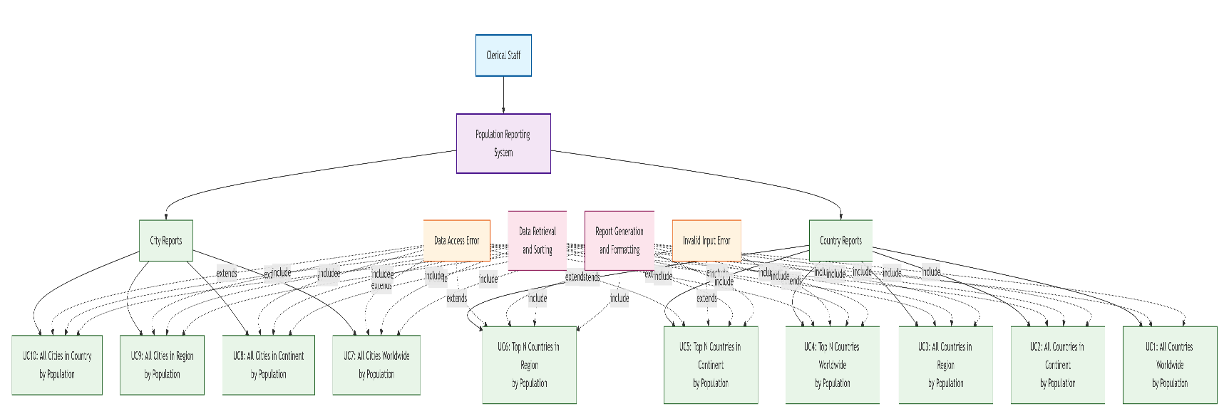

**Key UML Components Explained:**

**Actors:**

* **Primary Actor**: Clerical Staff (responsible for all report generation)

**Use Cases Grouped by Category:**

**Country Reports (C1-C6):**

* **UC1**: All countries worldwide (largest → smallest population)
* **UC2**: All countries in continent (largest → smallest population)
* **UC3**: All countries in region (largest → smallest population)
* **UC4**: Top N countries worldwide (user provides N)
* **UC5**: Top N countries in continent (user provides N)
* **UC6**: Top N countries in region (user provides N)

**City Reports (D1-D4):**

* **UC7**: All cities worldwide (largest → smallest population)
* **UC8**: All cities in continent (largest → smallest population)
* **UC9**: All cities in region (largest → smallest population)
* **UC10**: All cities in country (largest → smallest population)

**Relationships:**

**Extension Points (Error Handling):**

* **Data Access Error**: Affects UC2, UC3, UC4, UC5, UC6, UC7, UC8, UC9, UC10
* **Invalid Input Error**: Affects UC4, UC5, UC6 (where user provides N)

**Include Relationships (Common Functionality):**

* **Data Retrieval and Sorting**: Required by all use cases
* **Report Generation and Formatting**: Required by all use cases

**System Boundary:**

* **Population Reporting System**: Contains all use cases within the data management platform

**Preconditions (Applied to All):**

* User authentication and authorization
* Access to current, validated population data
* Proper system functionality

**Success Conditions:**

* Reports generated with correct sorting (largest → smallest population)
* Data presented in usable format for organizational needs

**Failed Conditions:**

* Data retrieval errors
* Invalid user inputs
* System access issues

